What is Docker?

Docker is a platform for developers and sysadmins to develop, deploy, and run applications with containers. The use of Linux containers to deploy applications is called containerization.

A container is launched by running an image. An image is an executable package that includes everything needed to run an application--the code, a runtime, libraries, environment variables, and configuration files.

Containers and virtual machines
A container runs natively on Linux and shares the kernel of the host machine with other containers. It runs a discrete process, taking no more memory than any other executable, making it lightweight.
By contrast, a virtual machine (VM) runs a full-blown “guest” operating system with virtual access to host resources through a hypervisor. In general, VMs provide an environment with more resources than most applications need.
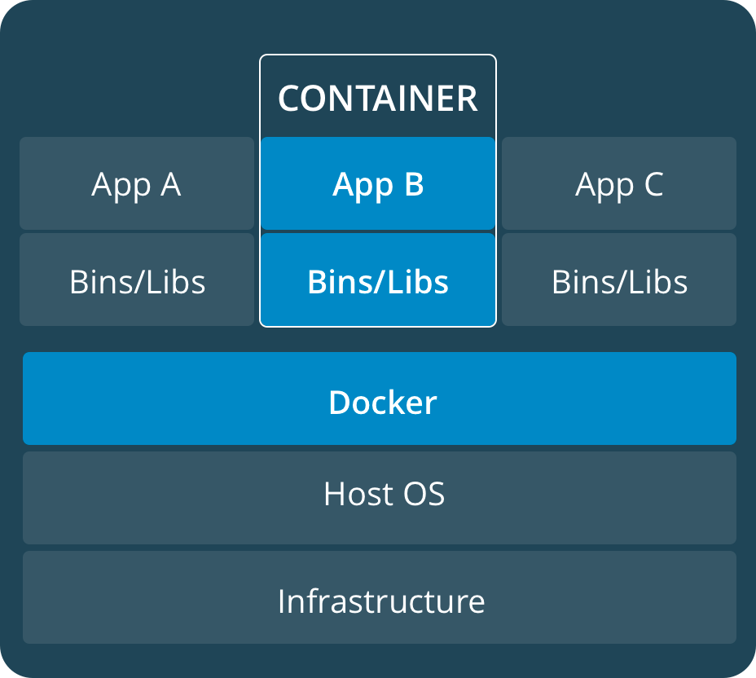
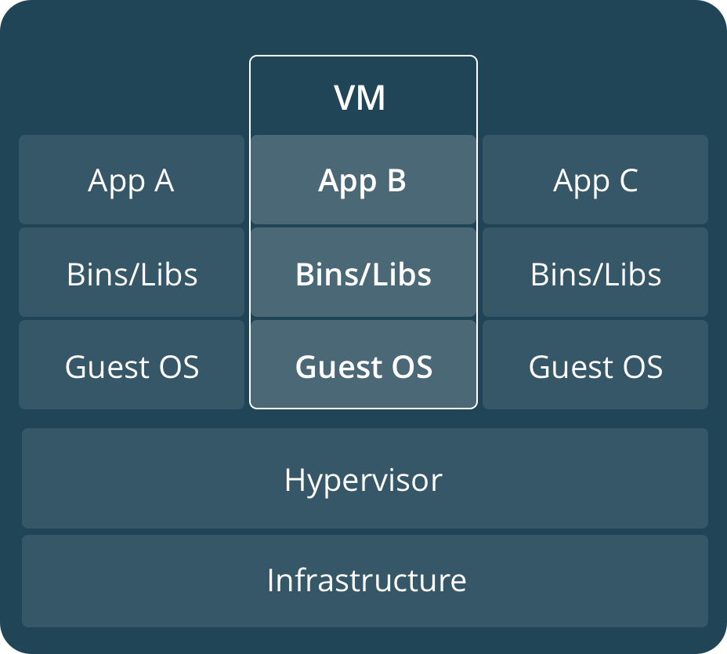

Dockerfile:

What is a Dockerfile?

A Dockerfile is a text document that contains all the commands a user could call on the command line to assemble an image. Using docker build users can create an automated build that executes several command-line instructions in succession

- Docker images are built from a base image.
-Base images are built up using simple instructions such as, RUN,ADD,COPY,CMD,ENTRYPOINT...etc
-Docker images are read only templates, from which containers are launched from.
-Each image consints of a series of layers using the union file system
-when you change an image, a new layer is created.

FROM tells docker, from which base image you want to base your image from.

The RUN command is used to run instructions against the image.

CMD sets default command and/or parameters, which can be overwritten from command line when docker container runs.

ENTRYPOINT configures a container that will run as an executable.

The COPY instruction copies new files or directories from <src> and adds them to the filesystem of the container at the path <dest>.

The ADD instruction copies new files, directories or remote file URLs from <src> and adds them to the filesystem of the image at the path <dest>.

ADD lets you do that too, but it also supports 2 other sources. First, you can use a URL instead of a local file / directory. Secondly, you can extract a tar file from the source directly into the destination.

.dockerignore is to prevent files from being added to the initial build context that is sent to the docker daemon when you do docker build, it doesn't create a global rule for excluding files from being created in all images generated by a Dockerfile.

Dockerfile Ex:

FROM ubuntu
RUN apt-get update
RUN apt-get install -y apache2 apache2-utils
RUN apt-get clean
EXPOSE 80
CMD /usr/sbin/apache2ctl -D FOREGROUND

Dockerfile ex 2 from project:

